Title of Abstract (Arial, 12 pt, centered, bolt)

John J. Johnson*, Second Author¹, Third Author², Other Authors^{1,2,3} (Arial, 12 pt, centered)

*author@empa.ch (email corresponding author)

¹Empa, Swiss Federal Laboratories of Materials Science and Technology, Switzerland
²Second affiliation, Country (Arial, 10 pt, centered, italic)
³Additional affiliation, Country (Arial, 10 pt, centered, italic)

Abstract body text in Arial, 10 pt, single space. Maximum 1 page without changing page margins or line spacing. Accepted file formats "doc", "docx".
Figures may be provided, but it is not mandatory. Select text wrapping for figures as "top and bottom". Group subfigures in external software and paste as single figure file. Label subfigures a), b), c) and provide caption explaining each subfigure.
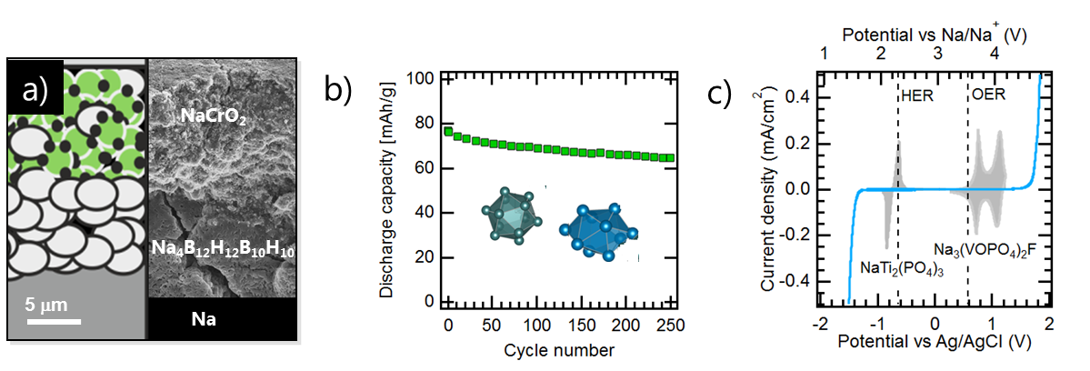

Figure 1: a) explanation for first subfigure, b) explanation for second subfigure, etc. (Arial, 10 pt)

More abstract body text in Arial, 10 pt, single space. References such as Ref. 1 should be provided according to the ACS style guide.² List all authors and do not use "et al." or similar abbreviations

We are looking forward to welcoming you to the Swiss & Surrounding Battery Days at Empa Academy on August 26-28.

References:

¹ K. Mizushima, P.C. Jones, P.J. Wiseman, J.B. Goodenough, Mater. Res. Bull. 1980, 15, 783-789
² A. M. Coghill, L. R. Garson, The ACS Style Guide, DOI: 10.1021/bk-2006-STYG

